IDEATION PHASE – DOCUMENT 1: BRAINSTORMING
Date | 06 November 2025
Team ID | NM2025TMID08793
Project Name | Lease Management
Maximum Marks | 4 Marks

Title: Brainstorming for “Lease Management”

BRAINSTORMING

Objective
The purpose of this brainstorming phase is to explore and evaluate multiple ideas to solve the challenges in traditional lease handling such as document mismanagement, payment delays, and lack of transparency. The goal is to identify a feasible technical solution — using Salesforce — to automate, track, and secure the leasing process between tenants and property owners.

Brainstorming Process
The brainstorming was conducted in three structured rounds:
Round | Focus Area
Ideation Round 1 | Listing all possible problems in lease handling and possible digital solutions
Ideation Round 2 | Shortlisting ideas based on feasibility, scalability, and user needs
Ideation Round 3 | Converting filtered ideas into Salesforce-based system workflows

Tools used: Miro, Notepad, Jam board, and team discussion calls.

Stakeholders Involved
Stakeholder | Role in Brainstorming | Contribution
Property  Owners | Shared real-life problems in managing multiple tenants | Explained rent follow-up, lease expiry issues
Tenants | Shared user experience issues | Reported lack of payment reminders & communication gaps
Real Estate  Agents | Provided market workflow insights | Suggested features like document verification & renewal alerts
Technical  Mentors | Guided Feasibility & Platform  Selection | Ensured the idea fits Salesforce ecosystem

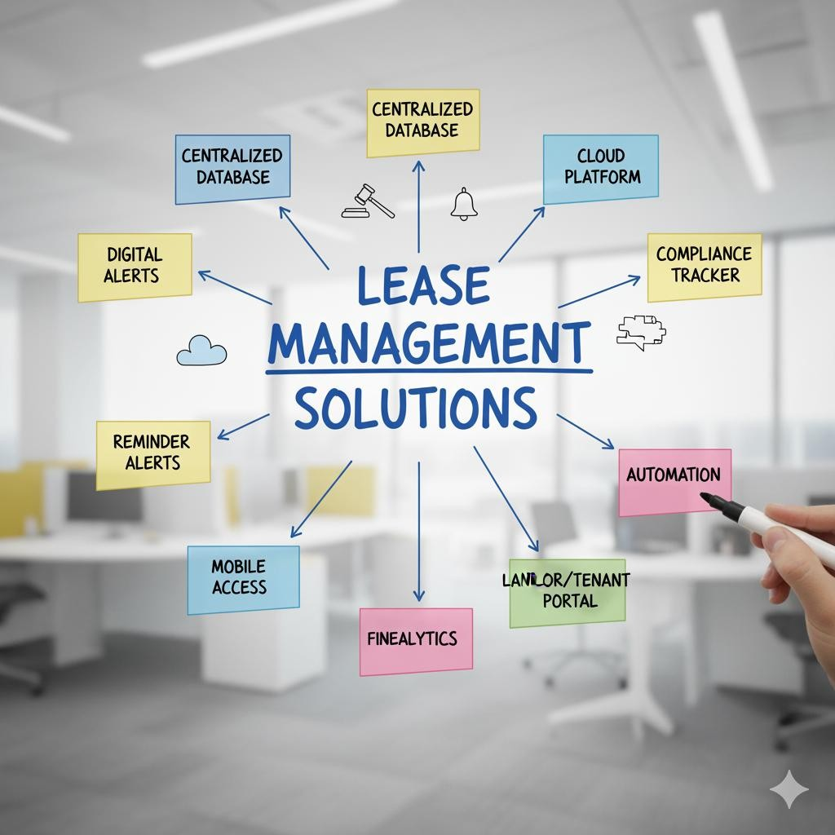

Idea Generation Methods
Method | Purpose
Mind Mapping | Mapped flow from Property → Lease → Tenant → Payment → Renewal
SCAMPER | Modified traditional lease process with automation & dashboards
Reverse  Brainstorming | Asked: "Why do lease agreements fail?" to expose root issues (late rent, lost papers, no reminders)

Consolidated Ideas
Idea No | Idea Description | Feasibility | Impact
1 | Centralized lease document storage | High | High
2 | Auto rent reminder & expiry alerts | Very High | Very High
3 | Payment tracking dashboard | High | High
4 | Tenant–Owner communication log | High | Medium
5 | AI-based rent prediction | Low | Moderate

Final selected direction: Salesforce-based Automated Lease Tracking System
Why?
- Available free dev org
- Easy automation with Flows
- Role-based access for Owner, Tenant & Admin
- Real-time dashboards and reports

Rationale for Choosing Salesforce
Salesforce provides:
- Custom Objects for Lease, Tenant, Property, Payments
- Automation using Flow, Email Alerts & Triggers
- Dashboards for overdue rent, upcoming renewals, tenant status
- Secure cloud platform with user role control

Outcome of Brainstorming
The finalized concept “Lease Management” is a cloud-based lease management solution that:
- Stores all lease contracts digitally
- Automates rent reminders & renewal alerts
- Tracks payments and communication
- Reduces disputes through transparent records
It is designed to replace manual lease handling with a structured, automated Salesforce solution.

